**Metroid Isolation**

**Plot**

It has been years since the events of the original events of Metroid 1 and everyone was safe. Samus Aran who was the main hero who defeated Mother Brain was rewarded greatly and became an official member of the Galactic Federation. However, there was one fear that loomed over everyone and that was the feeling that it was far from over.

Suddenly, there was a distress call at Talon IV and therefore Samus was appointed to check it out. Rumours have been going around that there have been independent hunters that have been attacking the Galactic Federation. Furthermore, some of these hunters have been apparently in cahoots with the Space Pirates in some secret bioweapon conspiracy. The Galactic Federation then set up a secret mission in order to ascertain the truth behind these rumours. Unfortunately, since the Federation was only recently founded and Samus having gone on her mission, there was not anybody who could do this mission until the main protagonist Sarah shows up. Sarah was then appointed to do this mission and off she went.

The first assignment was to infiltrate and explore through Planet Zebes to find clues on what the Space Pirates are planning. Within closer exploration, Sarah had found several dead carcasses lying on the floor. She had studied what they are and found out they were carcasses of one of many of the generals of the Space Pirates. She then had ventured into Tourian where she had hacked into the super computer and had found something odd. She had found some videos which contained the experiments of Talon IV.

The first video included powering up a space pirate dramatically by injecting them with something called Phazon. She then observes how this substance caused rapid growth to the point that it blows out their insides. The next video was about body duplication and how they were able to duplicate Ridley’s body several times over. The third video was heavily obscure but she managed to pick out what looked to be a tall looking purple ‘hunter’. Suddenly, chills sent down her spine as she realises who this hunter might be and what he says. He says the following, ‘Have you found the source? Get to mining so we can fulfil one phase of Project Dread. That damn accursed hunter will not leave us alone, she is being a pain in the neck. Fine! If she wants to come to us, we will let her along. *Bzzzzzt* Found you.” Sarah slips and the red alarm goes off alerting all space pirates nearby, in order to get out she needs to fight her way through Tourian and Brinstar.

As she is fighting her way through, she runs into several elite pirates and thanks to their attacks it caused a cave in. This was terrible as it meant she had to find a different way to escape Zebes without being noticed again. As she explored, she eventually enters the area known as Chozodia which was discovered by Samus. Sarah had previously researched heavily into this area and found that it was a hidden Chozo ruin that was left for the destined hero. It was said that the Chozo had left several artifacts in the hope that their hero would find them and end their war between the Space Pirates. Sarah was amazed at the intricate designs showing all the Chozo and what they were like. What was more interesting was that she saw a little drawing which indicated a child had drew it. More questions had loomed over Sarah and it started to make her determined to fulfil this mission. She found a secret exit, leading her to an exit undetected. Unfortunately, she could not find the hidden treasures, but she was glad that she gained more information based on this infamous substance Phazon.

Sarah got an immediate call from the Galactic Federation informing her to go to G.F.S Olympus. Sarah reached there and had been told to go to Planet Aether immediately without any real reason why. Sarah was confused and had insisted to ask why but no matter how much times she asked she got no answer. So, at the end she went there to see for herself to find the answers to her questions. When she got there, she found that the whole planet was filled with a corrupted blue gas and upon further inspection she found an old enemy phazon. Whilst helping the Luminoth clearing the last of the Phazon from Planet Aether she secretly scooped up a little of the phazon to study further on what it is. Upon further research done in secret, she found that there was more to this “liquid” than meets the eye. Sarah had found out that this “liquid” was more like a living being.

Sarah had moved onto experiment 2 of her little secret experiments where she then proceeded to bring the phazon out in the open. First, she tests if the phazon interacts on its own in the open air, but nothing happens. Next, she then tests it on other phazon and interestingly it turns bright blue. It also tries to converge back to the other phazon which indicates that they are dependent on each other and they are like smaller cells that form a bigger creature. She then noticed that it attached to physical materials and ended it made it more modified.

Within a couple of months, Sarah and the Galactic Federation had managed to reduce the corrupted atmosphere within Planet Aether. As the skies became clearer, everyone had noticed a giant meteor appeared and the Luminoth said that this meteor comes from a ‘Great Evil’. This gave an insight that sooner or later the Galactic Federation is going to have to be ready for this ‘Great Evil’. In order to combat this evil, the Galactic Federation created the PED suit. One thing loomed over Sarah’s head, yes, she learned more about Phazon, but this purple hunter was a problem and what was this Project Dread about.

After investing Aether, Sarah had started to suspect the Galactic Federation since they were not being clear on their actions. When asked by what she found out, she simply kept the important facts to herself and mentioned only the brief to them.

She was given a special request and that was to investigate SR388 for two reasons. One of those reasons were because it was the main home of Metroids and the second because there are rumours that the purple hunter was seen there. When asked about the identity, the leaders said “Sylux” and nothing more. Sarah set off to SR388 at once but found Samus already flying over. As a result, Sarah was annoyed and moved to a different region in SR388. This is because deep down she knows that wherever Samus is, she will finish the job no matter what so there is no point going in that region. Sarah had managed to find a hidden factory hidden deep down the fiery zones of SR388. She managed to find more hidden Chozo art (that was a surprise to her) showing the Chozo creating the first Metroids that combat against a parasite infection known as X.

Upon analysis from logs Sarah had collected in the factory, she found out that the X-parasites would first kill its opponents and then take over its body forming a monster. The only killers that could end the X-parasites were the Metroids and the Phazon they were emitting. Sarah then took notice of more Chozo art displaying a lot of political conflicts that the Chozo leaders were having with each other and their decisions on making more advanced tech. On one hand, some of them were warning that it goes against the laws of nature whereas the others had completely disagreed. This ended up on some of the last Chozo art that showed a mass slaughter on each other that ended with the Metroid adapting to this X parasite and mutated. Sarah then advanced but was sealed thanks to a sealed door, in order to open this door, it can only be identified with those that share the blood of the Chozo.

Sarah had no choice; she grabbed a broken slab and made a deep wound on her hands. For her it was more of a gamble since she hardly knew anybody that shared their blood 100%. When measured she was more shocked than ever before, the identity check revealed to her that she shared their blood 100%. Upon reflection on her past, Sarah does not even know much of her family and where they are now. When advancing, she comes to find wrecked weapons of the like no one has ever seen.

In the far back corner, she notices a mining machine codenamed “Diggernaut”. As she is checking this weapon out, Diggernaut suddenly wakes and starts destroying everything it see. It starts by chucking the other mechs at Sarah and unleashes lasers at her. She narrowly misses and proceeds to try to run under Diggernaut to see if she can somehow turn it off. As she does that Diggernaut thrusts its giant rolling arms at her, and Sarah uses it to jump on them and take a big leap towards him. She successfully jumps onto him and tries to find a way to stop Diggernaut.

Unfortunately, she malfunctions Diggernaut, and it proceeds to chuck her towards the wall. Diggernaut then digs across the wall and advance whilst Sarah sustains an injury. With great struggle, she gets back on her feet and notice two distinct shadows. She then proceeds towards them and points the beam at whoever was in front of her. “Show your hands this instant.”. “So, this is your pathetic friend Sylux. It seems she is flimsier than our other friend.”. To her surprise, she was face-to-face with the Galactic Federation’s enemies; Sylux and Proteus Ridley. “Now Ridley, that is no way to interact with someone who has also been a pain in the neck. How sad they made you into a lapdog just to fulfil their selfish goals.”. “What do you mean?” “ *chuckle* You truly do not know what they’re really like after all. You have sullied the Chozo’s name with your antics.” “What…. How do you know that? (angrily)” “Enough. That’s neither here nor there. I will kill you here and bring your head as a trophy of my revenge.”

In rage, Sarah had charged at Sylux and was then immediately grabbed by Proteus Ridley. Ridley then drags her across the wall and throws her onto the floor where he then roars whilst leaving the ruins to chase after Samus. A tense atmosphere began to stir between Sylux and Sarah as they face head-to-head for the first time. Sarah starts by dealing several strikes which was avoided with ease thanks to her previous injuries. She then gets dealt a low kick and then her life force got drained thanks to his wipe. After her blow, she tried to attack Sylux as many times as possible but no matter what Sylux kept nonchalantly avoiding. As Sylux deals his final blows he says, “Pathetic! So, this is the power of the TRUE Chozo. So sad that you could not fulfil up to our parents”. Sarah then proceeds to questions “Who are you?” and becomes unconscious.

After several hours, Sarah wakes up after a beating and struggles to walk forward. As long as she lives, she will not let Sylux succeed and cries out, “Why? Why couldn’t I win? Is it because I couldn’t face myself or is it that his convictions were stronger? Either way it does not matter because I lost, I am so hopeless.” As she struggles, she trips over and topples all over the stairs. She looks up and sees Chozo art displaying parents and two kids, these parents were one of the many lords of the Chozo and had led happy lives. The next Chozo art shows a city burning after a pirate raid and a child crying. The Chozo had found a baby and raised her like their own, that Chozo was none other than the Chozo parent. The next Chozo art shows that the three kids grew up and the eldest child goes with a specific group of Chozo. The parents start worrying about that child and starts searching for it but never finds him. As they take their last breath, they removed memory of the other two kids making sure they only remember their names, their brother and the Chozo.

Suddenly, she hears a kind voice “Oh Samus and Sarah, we could not find your older brother. *cough* Please forgive your beloved mother for what I am about to do, this is for the best…… Tell your older brother I love him”. As tears fall down her face, she stars to remember all the memories she had wished she had forgotten. Years ago, her older brother returns to the Chozo after a long expedition on creating further Chozo civilisations and learns the truth about his parents. At first, he was heavily remorseful, but the more time had passed she started to notice that he was being more unlike himself. One day, all three sat down and tried to talk to each other in private whilst having dinner. He explained his situation and how the Metroid Prime had escaped leaving only him alive, he showed his wound around his stomach.

The next morning, the two sisters woke up to see everything in ruins and on top of all of it was their older brother. “I am sorry, I have no choice.”, their older brother was banished and was never seen again until now.

Sarah is now more determined to find Sylux as she advances further down the ruins and finds something incredible. She found herself a new suit that was her parent’s last gift to her, it is known as the Chozo suit. Once she equipped her suit, she received her last message from her father.

“I do not know who I am talking to, but I am assuming that whoever found this suit is my beloved Sarah. She sees the right in everyone, anyways here is the truth. When we found your older brother, it was already too late we saw your brother and everyone else disappear off within a moment. I flew off without thinking to warn everyone in Zebes, SR388 and Talon IV. I was too late, Planet Zebes and Talon IV were already lost thanks to external threats like Metroid Prime and the Space Pirates. I managed to find the refugees in SR388 and had a meeting with my fellow lords. I had brought my case into motion and explained everyone to stop developing Metroid technology. It was hard but I succeeded. In exchange though, I was executed, and my family was hunted down because of greed. To my wife, Sarah, Samus, no to Sylux I’m sorry.”

Sarah rushes and finds her ship intact and pinpoints where Sylux is. She found his location and flies off to the Space Pirate Homeworld to face off against Sylux. It did not take longer to find Sylux and had fought against him. The amount of Strength she gained was scary and it only took a couple of strikes to defeat Sylux. Suddenly, Sylux sets up a massing self-destruction as a last-minute resort. After the explosion, the Galactic federation tried to find Sarah but found no sound. Did she escape or did she succumb to the explosion?

**Themes**

* Sci fi
* Exploration
* Betrayal
* Action
* Politics
* Truth

**Platform + Target Audience**

I would like this game to be on consoles like Nintendo Switch 2 and PC. One reason mainly for the Switch 2 is that it can be both a handheld and a home console which is great considering I would like the game to have two different modes so you can experience differently. The PC would be great because judging how limited the Switch can be, it can be a great way to further do modding on this game.

The target would mainly be for those who like sci-fi or are die hard fans of Metroid (mainly adults) seeing as the game mostly revolves around sci-fi themes. What is more, is that as whole a lot of fans would like to see more of Sylux or the fact that there could be other hunters in league with Sylux.

**Collectibles**

**Morph Ball**

This collectable allows Sarah to get super athletic abilities to the point she can curl up into a ball. This allows Sarah to go through different routes that enemies were not able to not anticipate, or you can use the morph ball to get other collectables like energy tanks.

**Grapple beam**

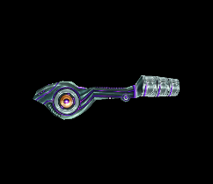Grapple beams allows Sarah to grapple onto each object allowing her to steal her foe’s weapons and use them to her advantage or use the other objects in the room to attack her opponents. She can also use the grapple beam to progress forward through specific areas, e.g., using it to drain power or using it as a rope.

**Missiles**

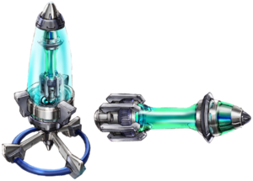Missiles gives a more powerful shot to enemies and like the grapple beam there are specific areas only accessible when using missiles. Later in the game, you can unlock new types of missiles you can use. You can recover your missiles by obtaining them from enemies or by upgrades.

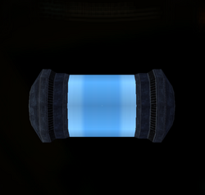**Energy Tanks**

Energy tanks allows Sarah to gain more power to her suit, if her suit loses all energy tasks then it is game over for Sarah. You can recover energy by defeating enemies or by finding new energy tanks. In order to obtain new energy tasks, it requires you to master techniques like bomb jumping or shine sparking.

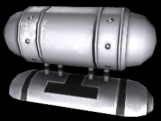There is also another type of energy tank known as reserve tanks which as the name implies are used as reserves in case Sarah’s suit runs out of power. When used you as the player needs to fill them back up by getting energy from enemies.

**Types of Enemies**

**Space Pirates**

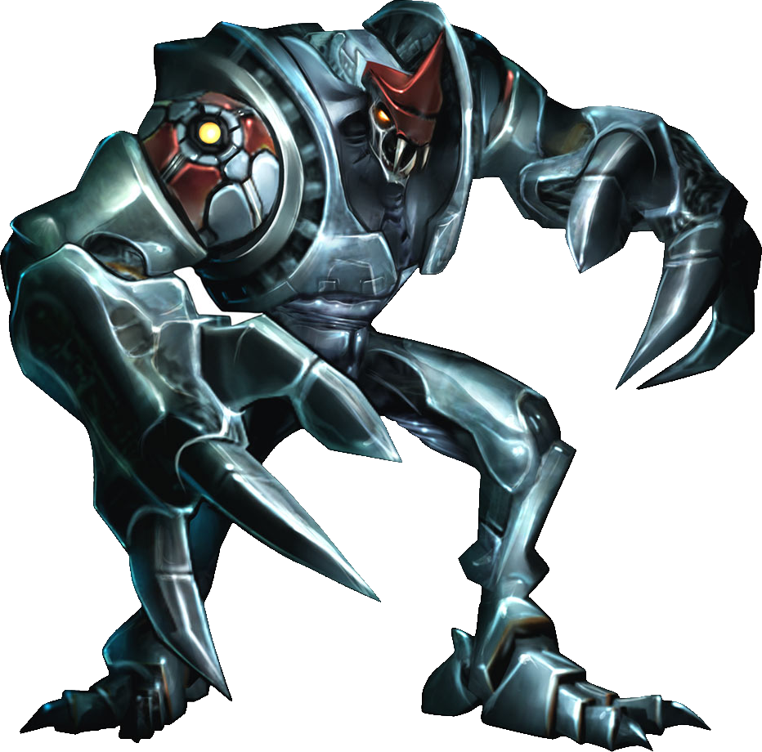The space pirates are an organisation that have caused a lot of chaos in the galaxies. Ridley one of the generals were responsible for the destruction of Samus’ world and her parents as he sliced them to pieces right in front of Samus.

It is also said that the pirate grunts have severe high intelligence and was responsible for many shady bio engineer experiments. One of these experiments were bio engineering a parasite to grow onto a massive scale which resulted in the parasite queen. Another experiment performed to revive the dead generals of the space pirates which ended in multiple failures. As a result, when Sarah and Samus enters areas like Chozodia or Tourian they can see carcasses of unidentifiable space pirates.

They also created the phazon cannon which sends unnatural meteors filled with phazon to Norion, Bryyo and Elysia.

The elite pirates are the most powerful of the space pirates, with each attack they send shock waves of massive proportions. The only way to deal damage to them is when they are trying to charge their strongest attack. If you are unable to stop them, they will shoot a massive laser causing Sarah an instant game over.

**X - Parasites**

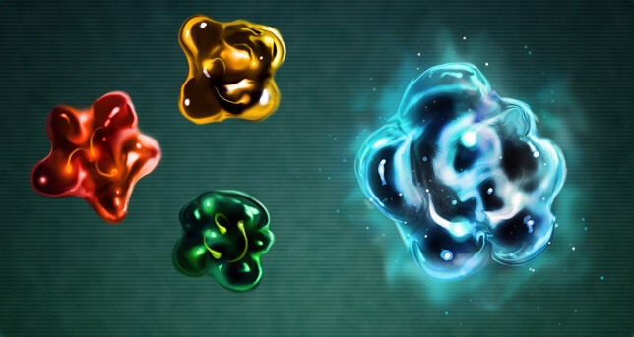The X-parasites are known for being one of the biggest evils in SR388. They consume their hosts and inhibits all their memories, traits and weaknesses. They then replicate their hosts two times folds and ends up becoming monsters. Some of their hosts includes nightmare, SA-X and Neo Ridley.

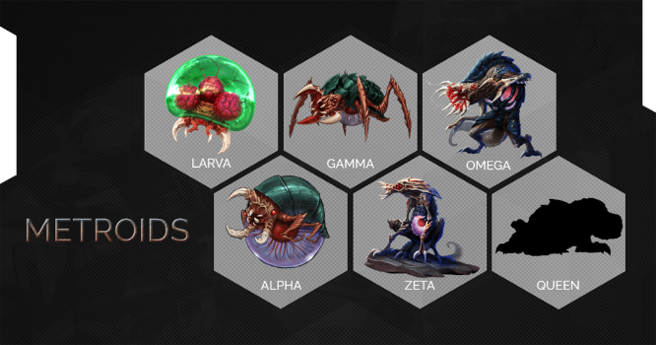

The biggest threat of the X-Parasites was that the Chozo had feared that the Metroids were able to mutate to extreme measures. The Metroids had mutated into a species of monsters that led many Chozo to be slaughtered.

**Visual Interface**

The main menu should show a zoomed-out view of all the planets nearby the Galactic Federation station, the biggest one being Zebes emphasising how important it is. Then Sarah’s ship shows up to show connotations of the beginning. If you click on settings, then it will zoom into the ship and show the ships controls. One of these options includes whether to play in 3D or 2D allowing you to play in different perspectives. Furthermore, there are more option settings like changing controls from either to motion controls or gyro control since people have different preferences.

I would like the main visual interface to be mostly in terms of lighting a bit dark because I want to emphasise the fact that you are alone. Furthermore, I believe it will also give more emphasise on external sound effects or shadows that pop back and forth. As a result, this would give the player a sense of unease and builds on a good atmosphere. This is what sci-fi games usually want to go with seeing as the player does not know what he is getting him/her-self involved in. This in effect, makes the player more motivated to explore further down the areas of each planet.

As for music, I think the music should be more sci-fi based but as well should give more of an ancient vibe. This further adds on the whole idea that you are about to explore the unknown and that adds excitement on what could be down there. Having a specific music play in an area gives a trigger or indication to the player that this room is there for a specific purpose, e.g., it may have an upgrade or could be a save room.

**Controls – How to play?**

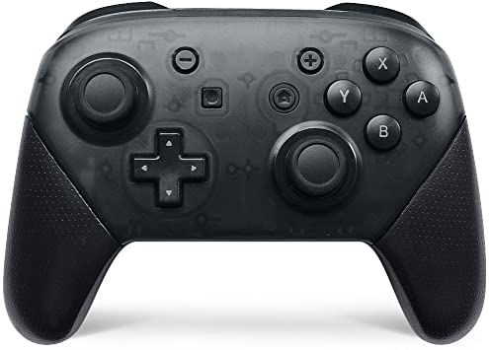

* X = jump
* Press x repeatedly = screw attack
* ZR = shot
* Hold ZR and let go = charged shot
* Down key D-pad = shoots missiles
* Up key D-pad = shoots super missiles
* Y = grapple beam
* Hold the C-pad in one direction and then press B = shine sparking
* ZL = activates morph ball
* ZL + b = bomb jumps
* ZL + a = morph ball jump
* ZL + hold X = performs boost ball
* ZL + L/R = spider ball
* L/R = scan visor
* A = locks on to enemies
* B = counter
* Space bar = jumps
* X = settings
* Left or Right Arrows = movement
* Down arrow = shoots missiles
* Up arrow = shoots super missiles
* A = shot
* Hold A and let go = charged shot
* G = grapple beam
* Shift = activates morph ball
* Shift + hold X = boost ball
* Shift + A = performs morph ball jump
* Shift + B = performs bomb jump
* Shift + Z = activates spider ball
* Z = scan visor
* Y = locks onto enemies
* B = counter
* Hold the C-pad in one direction and then press B = shine sparking

**Evaluation**

**What makes this game unique?**

This game is unique because even though this game is heavily based on the events of the original titles, there were a lot of factors that makes you want to know more about. One of these factors I explored were Sylux’s convictions for 1 reason. One is the fact that we do not know a lot about Sylux, all we know is that he hates the Galactic Federation for unknown reasons. Furthermore, he manages to follow Samus wherever she goes without fail and the fact he gets Galactic Federation weaponry without anyone knowing is a mystery. I want to add further character to this antagonist, and I feel there is no better way than adding an external bounty hunter trying to hunt him down.

This would further add character to them as well and personally I wanted to personally play on one idea. That ideas are whether there were any other bounty hunters who could have been influenced by Sylux or generally had a grudge against the federation. This was an interesting idea because it would be easier to link the main series with full swing and how Sarah, Samus and Sylux are related. Furthermore, I can essentially give the player situations which then would question their trust in the Federation as a result.

This game is essentially the in-betweens of the events and how each of the events in this game play a huge role in the originals and the games coming further in the future. There is a lot of politics that takes place which does not often happen in Metroid.

**Problems I faced when developing this concept**

* The story although needed a lot of thinking to further add to it which meant that I had to constantly read it
* I went in headfirst without planning which means that I had to constantly pause every now and then
* Some people may find it a little off putted at the fact that they may not play as Samus
* People might be thrown off at exploring several different planets

**How I intend to deal with these problems?**

For the first of my problems, the solutions are easy. The solution is to always plan and if you are stuck then look back and make more additions or alterations before moving on. The third problem can be solved by doing 2 things. I could give a unique personality to Sarah that feels like you are playing as Samus Aran but is different altogether. The second thing I could do is just add Samus as bonus content for new game plus and let players compare how each different character would experience the same situation. The fourth problem is not as straight forward as it looks, I need to make sure that each area has an atmosphere specifically built for them whilst still having that isolation feeling so people would enjoy it. On top of that, I need to arrange all the items in the correct order and make sure there is plenty for each area, so it does not feel empty to the player not restricting.

**Overview**

This is all I have so far, in the future I want to bring this idea in the open and make players experience what Sarah goes through. This is only the start to a bigger threat, with each coming title, you will be able to experience all what Sylux does and how Sarah combats it.

**References for Images**

* Amazon.(N/A).Wireless Switch Pro-Controller.[online image].Accessed at: <https://www.amazon.com/Switch-Controller-Wireless-Compatible-Nintendo/dp/B07R5RBJBZ>
* Currys PC World.(N/A).HP K2500 Wireless Keyboard.[online image].Accessed at: <https://www.currys.ie/ieen/computing-accessories/computer-accessories/mice-and-keyboards/keyboards/hp-k2500-wireless-keyboard-10199894-pdt.html>
* Willman1408.(N/A).X Parasite.[online image].Accessed at: <https://aliens.fandom.com/wiki/X_Parasite?file=Run_xparasitespecies_mf_thm.jpg>
* Embyr75. Elite Pirate MP1.(2013).[online image].Accessed at: <https://www.metroidwiki.org/wiki/File:Elite_Pirate_mp1_Artwork_01.png>
* MercurySteam.(2017).[online image].Accessed at: <https://www.resetera.com/threads/metroid-samus-returns-ot-r-edux-whats-past-is-prologue.1102/#lg=_xfUid-4-1623072395&slide=0>
* Dr Anonymous.(N/A).[online image].Accessed at: <https://metroid.fandom.com/wiki/Energy_Tank?file=Mp2_energy_tank.png>
* McKaners.(2012).[online image].Accessed at: <https://www.turbosquid.com/3d-models/metroid---reserve-tank-max/689195>
* MetroidKing.(2017).[online image].Accessed at: <https://www.metroidwiki.org/wiki/File:Missile_Expansion.png>
* The Resource Model.(N/A).[online image].Accessed at: <https://www.models-resource.com/gamecube/metroidprime/model/26737/>